**Images**

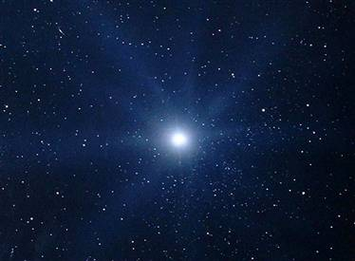

White Dwarf: <http://www.dailygalaxy.com/my_weblog/2013/02/-white-dwarf-stars-offer-best-potential-to-identify-habitable-planets.html>

Image Credit: Jonathan Saurine/Science Vault

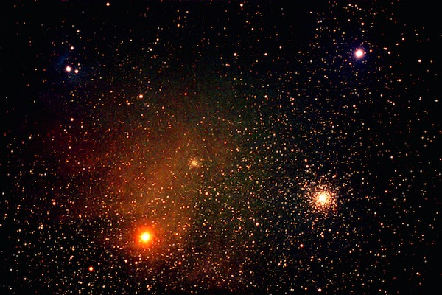Red Giant: Antares

<http://earthsky.org/brightest-stars/antares-rivals-mars-as-the-scorpions-heart>

Image Credit: Stargazerbob@aol.com

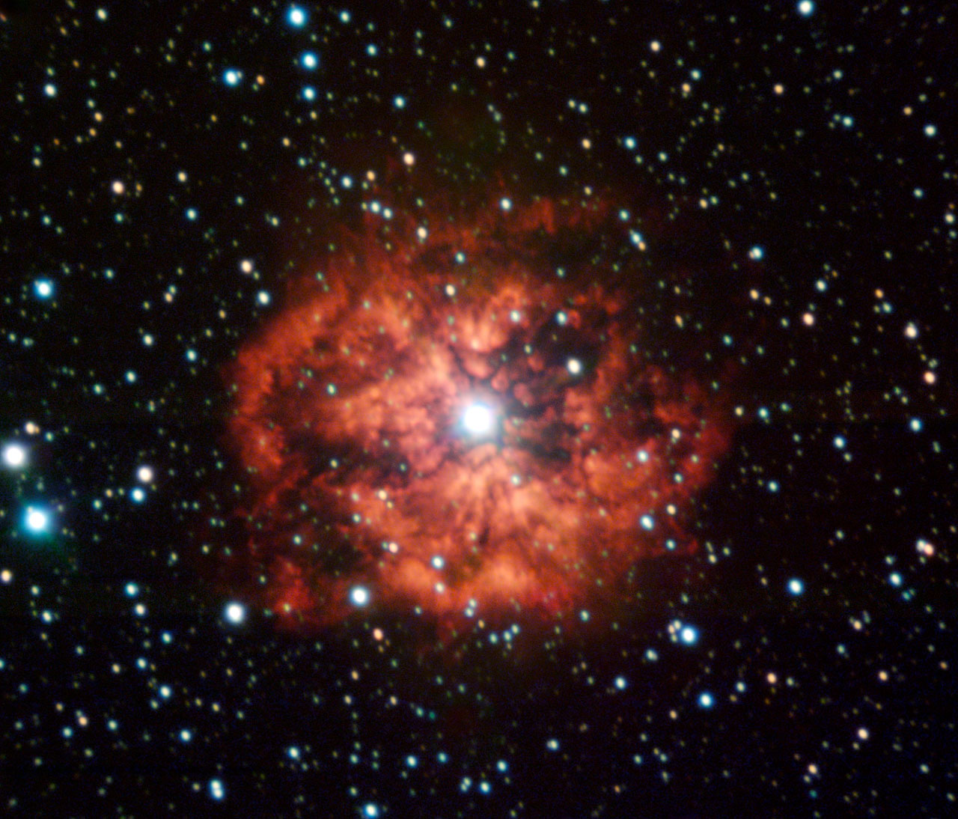

Wolf-Rayet: M1-67

<http://www.eso.org/public/archives/images/screen/wr124.jpg>

Credit: ESO

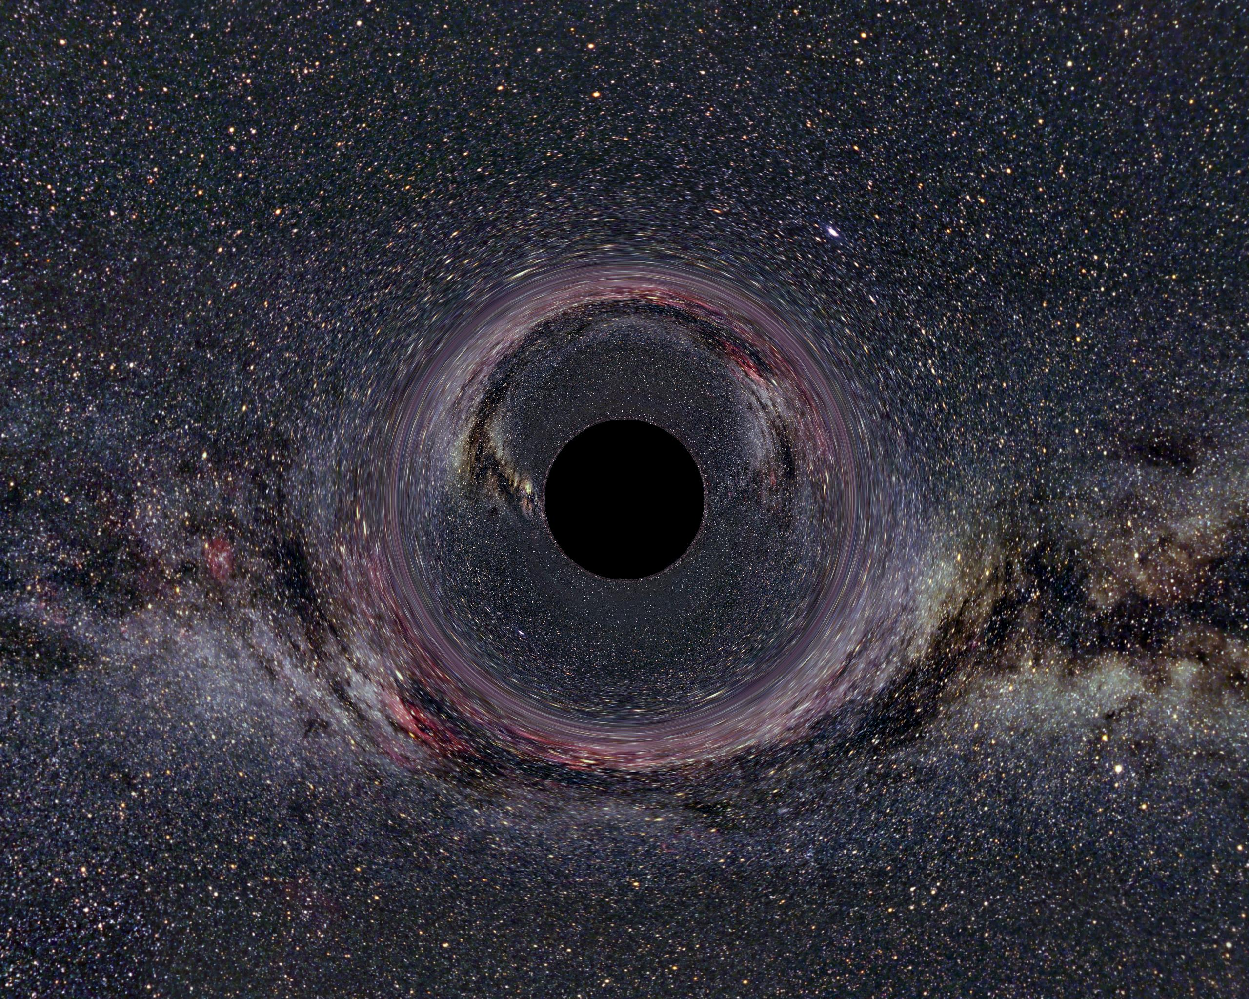Black Hole

<http://www.spacetimetravel.org/galerie/sl218.jpg>

Author: : [Ute Kraus](http://www.spacetimetravel.org/impressum.html) (background Milky Way panorama: [Axel Mellinger](http://home.arcor-online.de/axel.mellinger/allsky.html)xternal link)

**License**: This image is licensed under "[Creative Commons](http://creativecommons.org/)xternal link [Attribution-Share Alike 2.0 Germany](http://creativecommons.org/licenses/by-sa/2.0/de/deed.en)xternal link" (abbreviated ["cc-by-sa/2.0/de/"](http://creativecommons.org/licenses/by-sa/2.0/de/deed.en)xternal link).

Please acknowledge as in the figure caption.

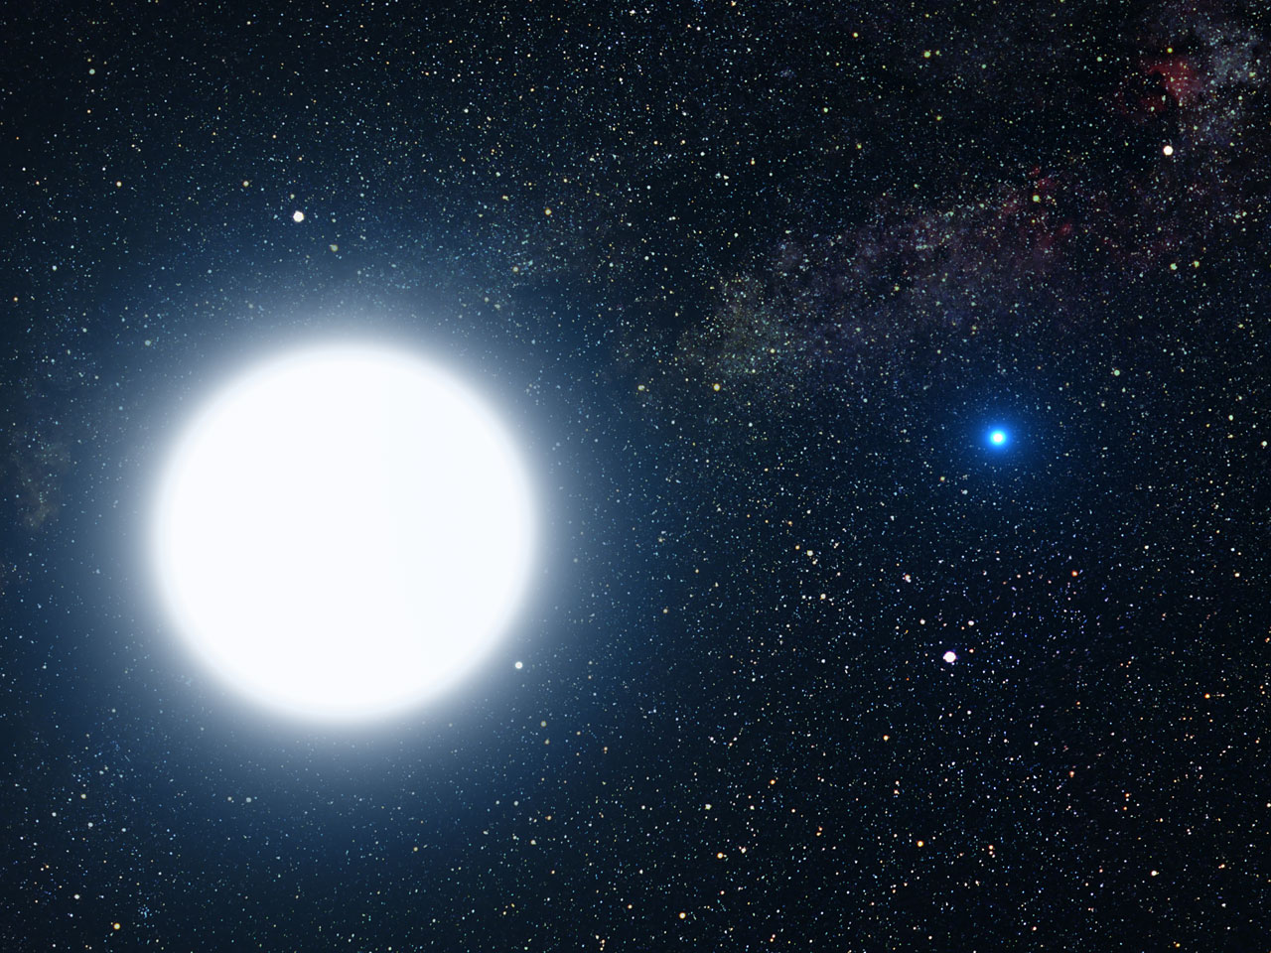High Mass MS (Sirius A & B)

<http://www.spacetelescope.org/images/heic0516b/>

Credit: [NASA](http://www.nasa.gov/), [ESA](http://www.esa.int/) and G. Bacon ([STScI](http://www.stsci.edu/))

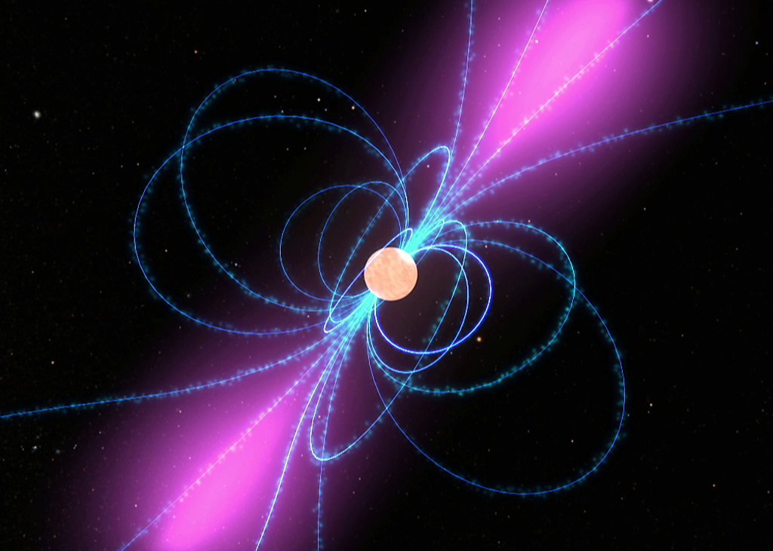

Neutron Star Diagram

<http://www.nasa.gov/images/content/283511main_fermigrop_pulsarmodel_HI.jpg>

Editor:[Dr. Tony Phillips](mailto:james.a.phillips@earthlink.net)

Credit: [Science@NASA](http://science.nasa.gov/science-news/science-at-nasa/2008/17oct_gammaraypulsar/)

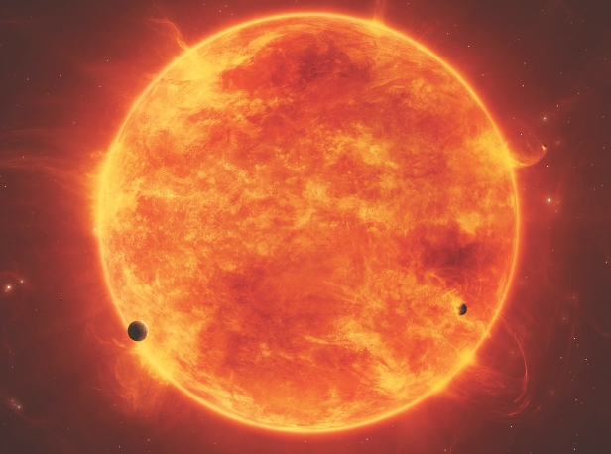Red Dwarf Main Sequence

<http://www.spaceanswers.com/wp-content/uploads/2013/01/Red-dwarf-main-image.jpg>

Credit: (Non stated) – [www.spaceanswers.com](http://www.spaceanswers.com) / All About Space Magazine